Project Design Phase Solution Architecture

Date | 17 February 2026
Team ID | LTVIP2026TMIDS66150
Project Name | Prosperity Prognosticator: Machine Learning for Startup Success Prediction
Maximum Marks | 4 Marks

Solution Architecture:

Solution architecture is a structured process that bridges the gap between business challenges and technical implementation. In the Prosperity Prognosticator project, the solution architecture defines how machine learning techniques are used to predict startup success and how the system components interact to deliver accurate and reliable predictions.

The goals of the solution architecture for this project are to:

Identify an effective machine learning–based solution to address the uncertainty in startup success prediction.

Describe the structure, behavior, and interaction of system components to stakeholders.

Define system features, development phases, and solution requirements.

Provide clear technical specifications for development, deployment, and maintenance of the solution.

🔷 Architecture Description

The solution architecture consists of a web-based user interface, a backend application layer, and a machine learning prediction module.

Users (entrepreneurs or investors) interact with the system through a web interface to input startup-related details. The backend application processes the inputs and forwards them to the trained machine learning model. The model, trained on historical startup datasets, analyzes the inputs and generates a prediction indicating the likelihood of startup success.

The system also includes data preprocessing, model evaluation, and model storage components to ensure accuracy, reliability, and reusability. The architecture supports modular design, making it scalable and easy to enhance in the future.

🔷 Key Architectural Components

User Interface (UI): Allows users to enter startup data and view prediction results.

Application Layer: Handles input validation, data flow, and communication with the ML model.

Data Preprocessing Module: Cleans and prepares historical startup data.

Machine Learning Model: Predicts startup success using trained algorithms.

Evaluation Module: Assesses model performance using standard metrics.

Data & Model Storage: Stores datasets and trained models for reuse.

Example - Solution Architecture Diagram:
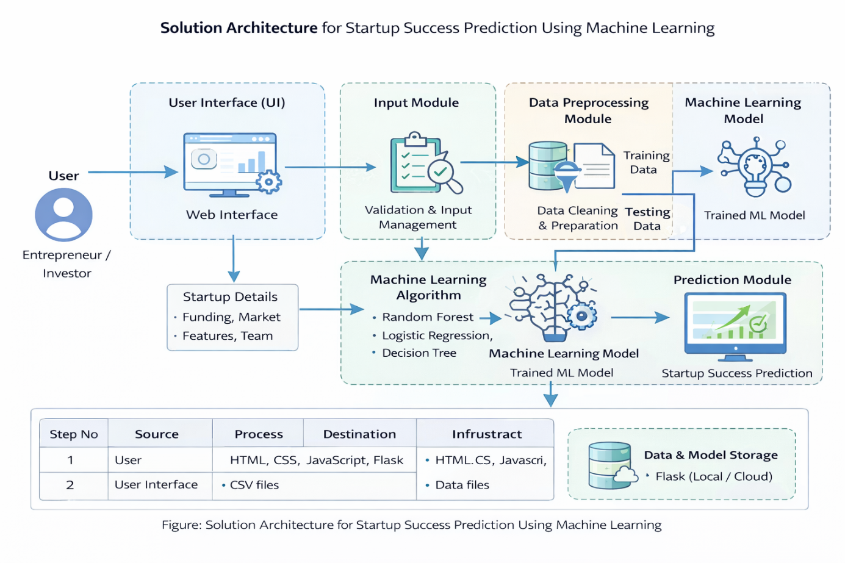
Reference: Self-defined solution architecture based on project requirements and team discussion

